A Guide to Science Department Door Signs
General Guidelines:
- If you don’t know whether or not something is safe, don’t assume it is. Either ask lab personnel about it, or leave it alone entirely. Remember that you always have the right to refuse any work you believe may be unsafe.
- All chemical spills are the responsibility of lab personnel. Regardless of whether or not you are comfortable dealing with the chemical in question, let them clean it up.
- A lot of very dangerous chemicals look like water. Unless you are absolutely certain that a spill is only water, leave it alone.
Hazard Levels:
Colour | Interpretation
 | No unusual hazards. You can treat this like any other classroom.
!!! | Moderate hazard. Do not enter unless you’ve been trained in handling the hazards present, and lab personnel have pointed out the hazards.
!!!!! | Severe hazard. Do not enter unless a member of the lab is present to ensure your safety.

Hazard Symbols:
Symbol | Hazard Description/Provisions
  GAS CYLINDER | Compressed gas cylinder(s) present. Exercise caution around any unsecured cylinders. Keep sparks and flames away from cylinders.  Gases under pressure.  The gas cylinder pictogram used for the following classes and categories:  - Gases under pressure (Compressed gas, Liquefied gas, Refrigerated liquefied gas, and Dissolved gas)  - Chemicals under pressure (Category 1**, 2** and 3)
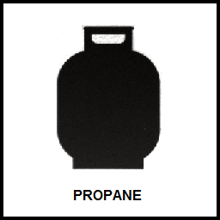 | Propane lines present. Ensure all valves are closed before beginning work. Keep sparks and flames away from valves.
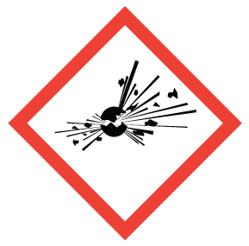  EXPLOSION RISK | Risk of explosion. Consult lab personnel for more details.  Explosion or reactivity hazards.  The exploding bomb pictogram used for the following classes and categories:  - Gases under pressure (Compressed gas, Liquefied gas, Refrigerated liquefied gas, and Dissolved gas)  - Chemicals under pressure (Category 1**, 2** and 3)
 | Heavy machinery present. Ensure machines are locked out before working with or near them (tentative, to be removed if lockout procedures not available). Do not attempt to operate machinery. Consult lab personnel for more details.
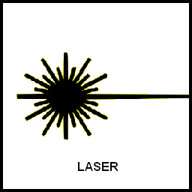 | Lasers present. Do not enter while in operation, and do not attempt to operate device.
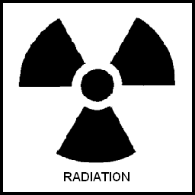 | Source(s) of radiation present. Consult lab personnel for more details.
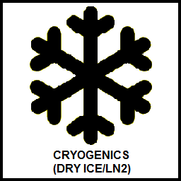 | Liquid nitrogen or dry ice present. Avoid contact. Do not inhale vapours.
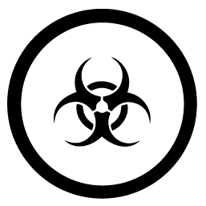  BIOHAZARDOUS INFECTIOUS MATERIALS | Biohazardous material present. Avoid anything identified as biohazardous. Consult lab personnel for more details.  Organisms or toxins that can cause disease in people or animals.  The biohazardous infections materials pictogram used for the following classes and categories:  - Biohazardous Infectious Materials (Category 1)
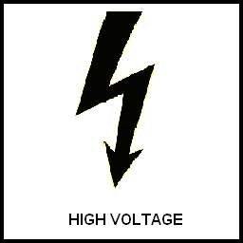 | High voltage equipment present. Ensure equipment is locked out before working in lab (tentative, to be removed if lockout procedures not available).
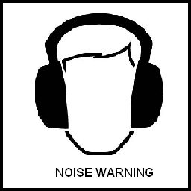 | High noise levels. Do not enter without hearing protection.
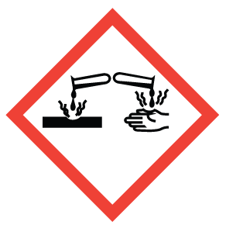  CORROSIVE MATERIALS  (ACIDS/BASES) | Corrosive materials present. Exercise caution around any spilled substances. If a chemical is spilled, evacuate lab immediately and notify appropriate lab personnel.  Corrosive damage to metals, as well as skin, eyes.  The corrosion pictogram used for the following classes and categories:  - Corrosive to metals (Category 1)  - Skin corrosion/irritation – Skin corrosion (Category 1, 1A, 1B and 1C)  - Serious eye damage/eye irritation – Serious eye damage (Category 1)
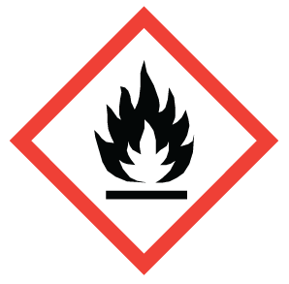  FLAMMABLE SUBSTANCES | Flammable substances present. Avoid generating sparks or flames. Report any chemical odours to lab personnel.  Fire hazards.  The flame pictogram used for the following classes and categories:  - Flammable gases (Category 1A and 1B Flammable gas; Category 1A Chemically unstable gas (A and B); Category 1A Pyrophoric gas)  - Aerosols (Category 1 and 2)  - Flammable liquids (Category 1, 2 and 3)  - Flammable solids (Category 1 and 2)  - Pyrophoric liquids (Category 1)  - Pyrophoric solids (Category 1)  - Self-heating substances and mixtures (Category 1 and 2)  - Substances and mixtures which, in contact with water, emit flammable gases (Category 1, 2 and 3)  - Self-reactive substances and mixtures (Types B*, C, D, E and F)  - Organic peroxides (Types B*, C, D, E and F)  - Chemicals under pressure (Category 1** and 2**)
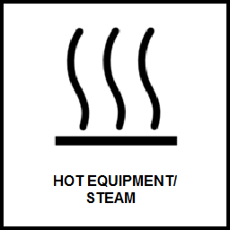 | Equipment may be very hot and/or hot steam may be generated. Exercise caution around equipment and steam outlets.
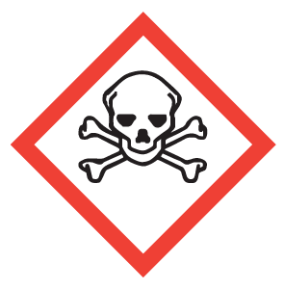  TOXIC MATERIALS | Toxic materials present. Do not touch, ingest, or inhale any unfamiliar substances. If a spill is noticed, or a chemical is spilled, evacuate lab immediately and notify appropriate lab personnel. Report any chemical odours to lab personnel.  Can cause death or toxicity with short exposure to small amounts.  The skull and crossbones pictogram used for the following classes and categories:  - Acute toxicity –  - Oral (Category 1, 2 and 3)  - Dermal (Category 1, 2 and 3)  - Inhalation (Category 1, 2 and 3)
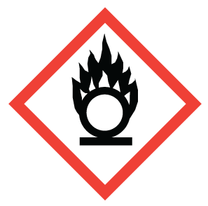  OXIDIZERS | Oxidizing agents present. Do not allow flammable material to come into contact with any substances in this laboratory. If a chemical is spilled, evacuate lab immediately and notify appropriate lab personnel.  The flame over circle pictogram used for the following classes and categories:  - Oxidizing gases (Category 1)  - Oxidizing liquids (Category 1, 2 and 3)  - Oxidizing solids (Category 1, 2 and 3)

* Both the Flame and Explosive pictograms are used for Self-reactive substances and mixtures (Type B) and Organic peroxides (Type B).
** Both the Flame and Cylinder pictograms are used for Chemicals under pressure, categories 1 and 2.

